**INFERENTIAL STATISTICS**

# LAB # 04



# Fall 2021

[**Data Analytics Lab**](https://classroom.google.com/u/0/c/MzA5OTAyNzE2MzM2)

Submitted by:

**Iram Noor: 18pwcse1711**

**Hudabia Faiz: 18pwcse1729**

**Shah Raza:18pwcse1658**

“On my honor, as student of University of Engineering and Technology, I have neither given nor received unauthorized assistance on this academic work.”

Student Signature: ______________

Submitted to:

# Engr. Mian Ibad Ali Shah

December 10, 2021

Department of Computer Systems Engineering

University of Engineering and Technology, Peshawar

**Task #1: Calculate the confidence intervals for men shoes sales in the USA, this time based on a bigger sample - 2015-2016.**

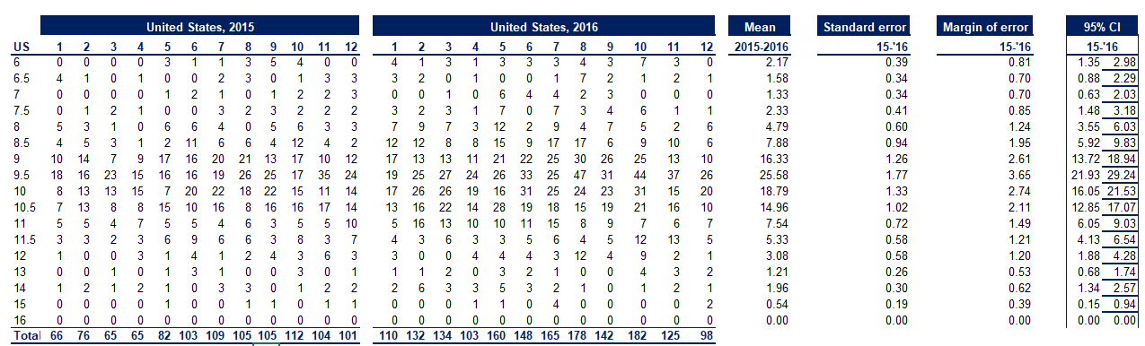

**Task #2: Compare the results with the confidence intervals when the sample was based just on 2016, as in class.**

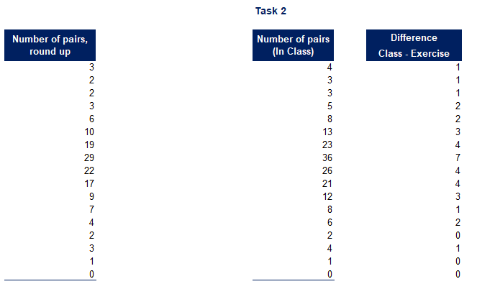

**Task #3:** **Estimate the 90% confidence interval for the same task as the lesson.**

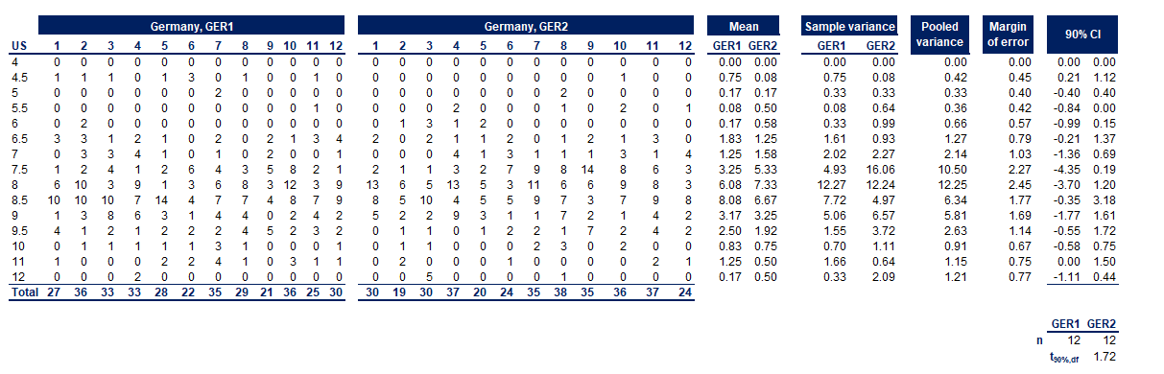

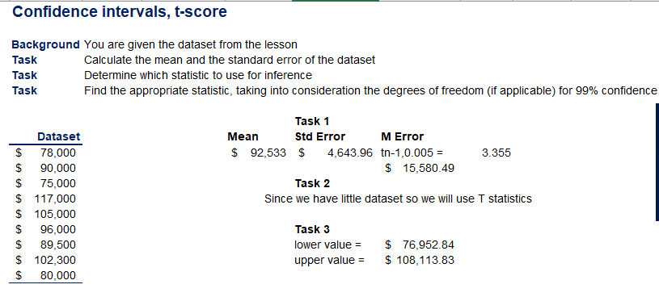

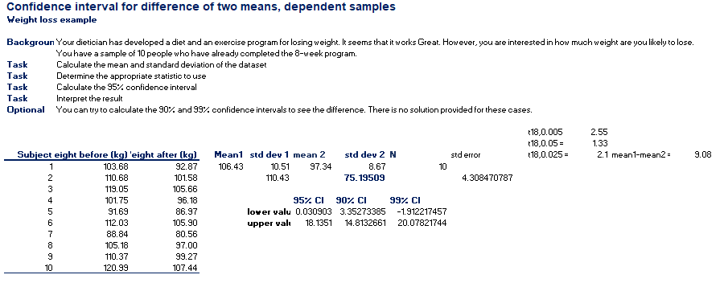

It seems like if you follow the diet plan developed by dietician then we are 95% confident that you'll lose the weight between 0.03kg to 18.13kgs and 90% confident that you'll lose the weight between 3.3kg to 14.8kgs and 99% confident that you'll lose the weight between -1.91kg to 20.07kgs, here negative sign means that there is very little probability that you'll gain 1.91kg weight.

